NAME: ______________________________________ DATE: ________________ CLASS PERIOD: ________

STUDENT HANDOUT: APPALACHIAN STREAM CONSERVATION

Endangered species I know about:

What do these species have in common?

How about the Eastern hellbender?
- Very sensitive to __________________________ from __________________________ and __________________________ (breathes through its ______________, lays eggs underwater)
- ______________________________ leads to heavy ________________________________ that can eliminate good nesting habitat by ______________________________________________________
- Listed as endangered or threatened by many _________________ throughout its range
- Denied listing by the federal government under the _______________________________________ in April 2019

What’s happening in your state?
Here are a few examples.

Pennsylvania
- The Coldwater Heritage Partnership is one of many organizations offering grants for projects that prioritize freshwater conservation across PA
- Efforts include protection and replanting of riparian buffer zones, removal of invasive species, and monitoring native trout populations
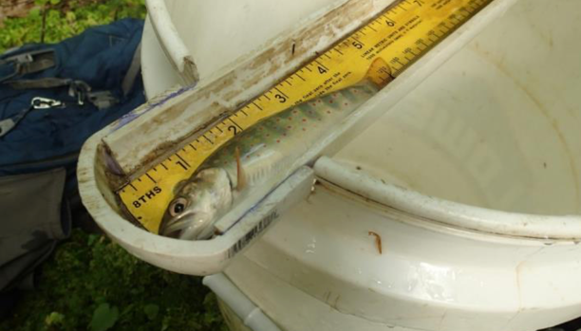
Maryland
- Maryland Biological Stream Survey
- Assesses diversity and stream health across MD
- Identifies impacts of climate change, acidic deposition, and other stressors on populations of stream species
- Conducted several times since 1995, interactive map shows status of streams across the state
West Virginia
- West Virginia Rivers Coalition
- Prioritizes state legislation targeting water pollution, site clean-up by bankrupted coal companies, and pipeline development projects
- Focus on community involvement and education
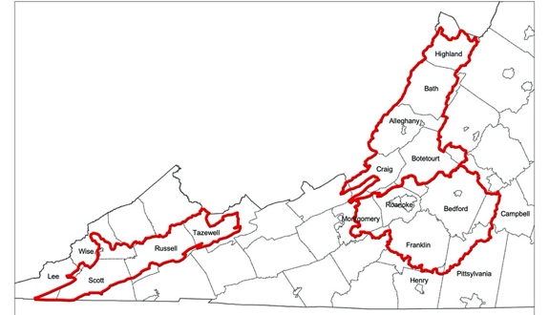
Virginia
- Fish and Wildlife Service targeting 3 main watershed areas: Upper Clinch River, Upper James River, and Upper Roanoke River.
- Chosen for the large number of threatened and endangered species that live there
- Efforts include livestock exclusion fences, creation of wooded buffer zones, and stabilizing stream banks.
Kentucky
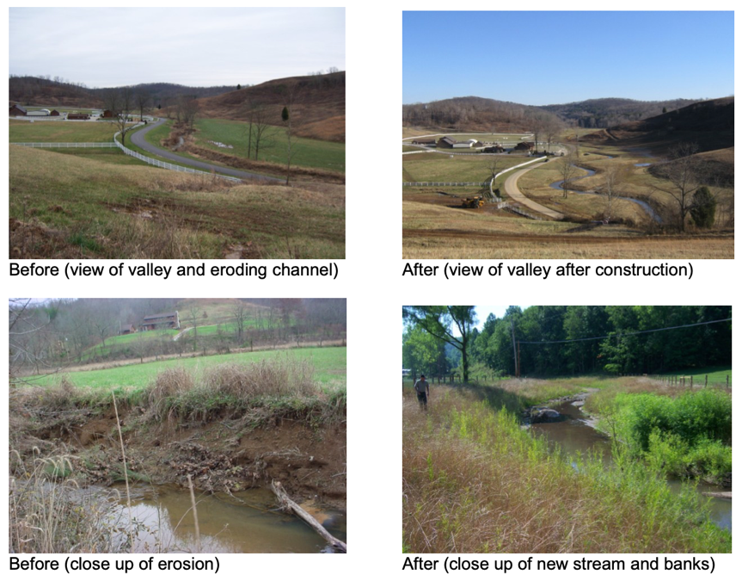
- Kentucky Stream Team program (KY Fish and Wildlife Resources)
- Qualifying landowners receive free repairs to eroding and unstable streams
  - Constructing new stream channels
  - Installing rock or wood structures to direct flow and reduce erosion
  - Planting trees
North Carolina
- North Carolina Land and Water Fund
- Projects focus on:
  - Restoring degraded streams (preventing bank erosion, repairing and protecting riparian buffer zones)
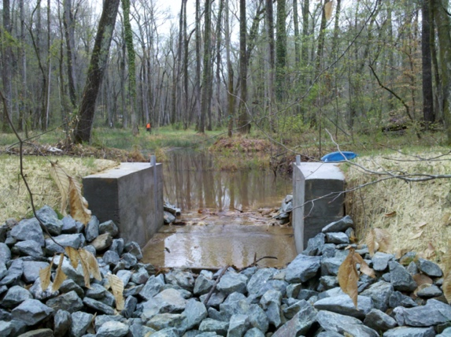
  - Stormwater treatment to protect habitats downstream from urban areas
Tennessee
- The Nature Conservancy’s Tennessee River and Cumberland River program
- Focus on:
  - Removing aquatic barriers like dams
  - Improving agricultural practices to lessen their impact on streams

What are some common themes across these different states when it comes to stream conservation and restoration? What are some practices that you notice are similar from state to state?
Write them here!

