NAME: ________________________________________ DATE: ________________ CLASS PERIOD: ______

NOTES SHEET: STREAM FOOD WEBS

Important vocabulary:
- _________________: dead _______________ and _______________ material
  - Where does most stream detritus come from?
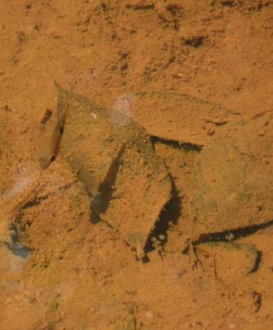

- ______________________: an organism that consumes detritus
- ______________________: an organism that makes its own food ( ____________ and _____________ ___________________________ )
- ______________________: organism that cannot make its own food and must ________ other organisms
- ______________________: the position an organism occupies in a ____________________

“Brown” vs. “Green” food webs
- What forms the base of most food webs that you know of?
  - ______________!
  - These ____________________-based food webs are sometimes called ____________ food webs
- In some ecosystems, ______________________ and other decaying organic material is the base of the food web!
  - These ____________________-based food webs are sometimes called ____________ food webs

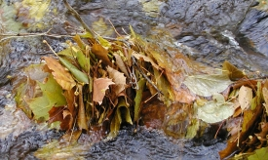
Are your rivers and streams “brown” or “green”?
- Leaf litter from surrounding trees forms the base of the food web in ____________________________ streams in Appalachia = more “brown”
- Leaf detritus input from terrestrial (_________) ecosystems around streams and rivers is HUGELY important!
- As stream order increases, rivers ______________, ________________________, and more plants are able to grow = more “green

Food web stability
- A ______________ food web is less likely to be affected by ________________________
- More complex food webs, with more __________ between organisms, are generally more stable than those with fewer links
- This is why each species in a food web is important! _____________ in one can affect many others.

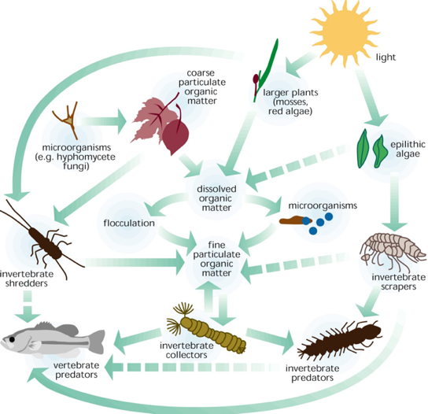
Aquatic/Terrestrial Links
- ______________________________________________: when things are passed from one ecosystem to another
  - ______________________
  - ______________________
- In streams, this link is very important
  - ______________________ from trees is #1 source of nutrients
  - Many terrestrial __________________ (dragonflies, stoneflies, and MANY others) spend the early parts of their lifecycle in streams before leaving to become adults

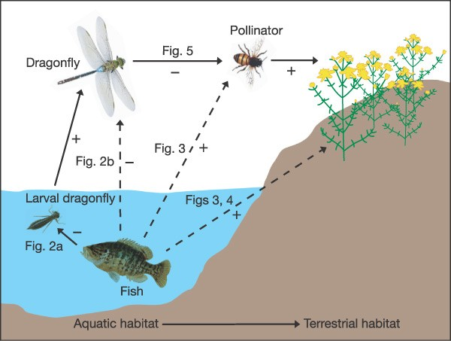
The importance of predators
- Predators can impact both the _______________________ and ______________________ (how many there are) of prey
- These effects can be transmitted down through the food web, affecting many other organisms, even in other ecosystems!

How does the hellbender fit in?
- Hellbenders primarily eat ________________________ and small bottom-dwelling ____________
- Help to maintain balance in crayfish populations – _________ of their diet!
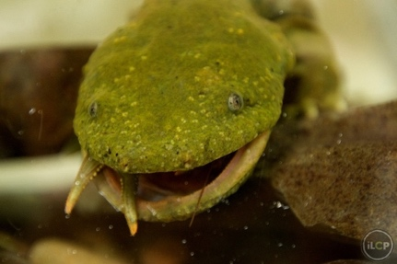
- Myth: ”Hellbenders eat fish and the eggs of fish that I like to fish for!”
  - No _________________ have ever been found in a hellbender’s stomach
  - No evidence for impact on ____________________________

