ORGANISM LIST:
Brook trout
Rosyside dace
River chub
Rosefin shiner
Southern two-lined salamander
Dragonfly larvae
Damselfly larvae
Mayfly larvae
Stonefly larvae
Dobsonfly larvae (hellgrammite)
Water penny
Great blue heron
Appalachian brook crayfish
Northern water snake
Benthic algae
Leaf detritus
Leech
Belted kingfisher
Freshwater amphipod
Asian clam

Brook trout  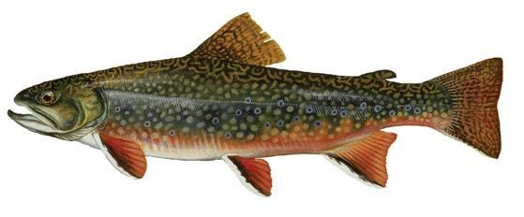 | Scientific name:  What does it eat?  What are its predators?  Interesting fact:
Rosyside dace  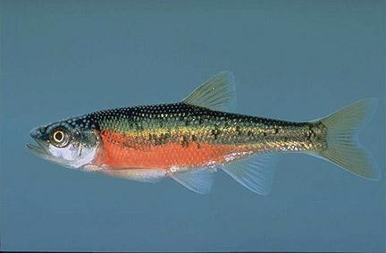 | Scientific name:  What does it eat?  What are its predators?  Interesting fact:
River chub  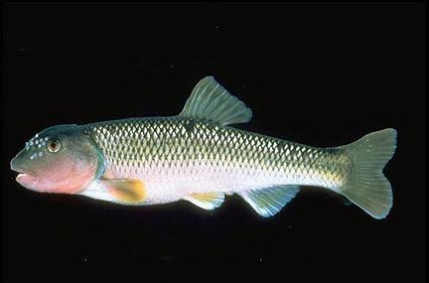 | Scientific name:  What does it eat?  What are its predators?  Interesting fact:
Rosefin shiner  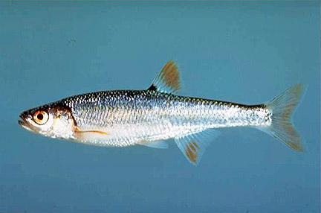 | Scientific name:  What does it eat?  What are its predators?  Interesting fact:
Southern two-lined salamander  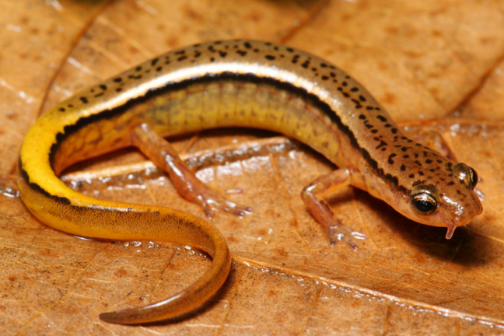 | Scientific name:  What does it eat?  What are its predators?  Interesting fact:
Dragonfly larvae  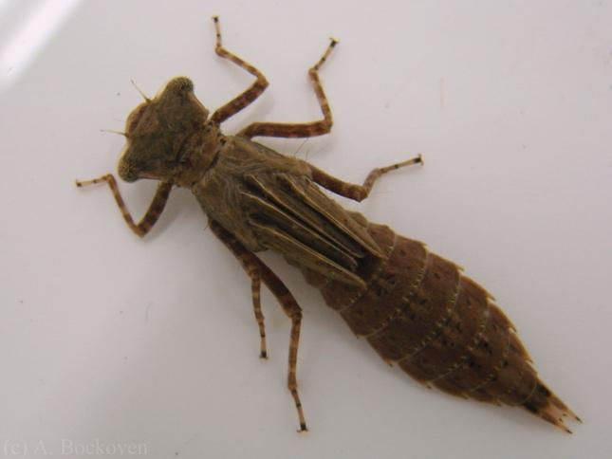 | Scientific name:  What does it eat?  What are its predators?  Interesting fact:
Damselfly larvae  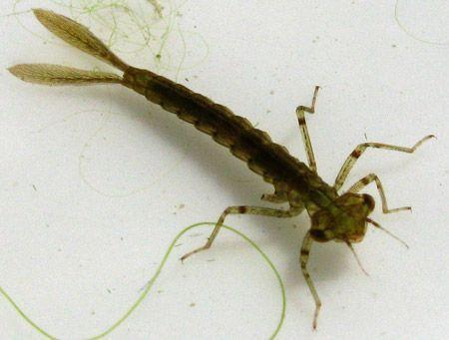 | Scientific name:  What does it eat?  What are its predators?  Interesting fact:
Mayfly larvae  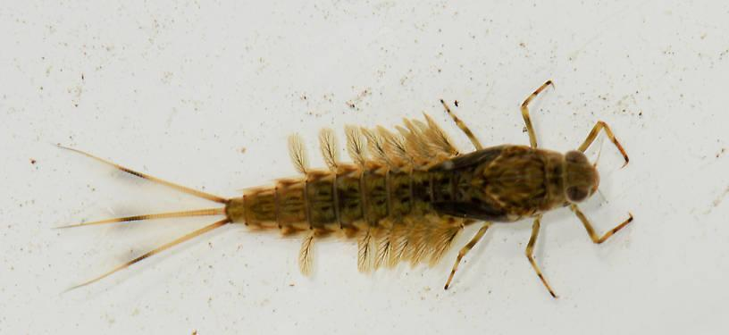 | Scientific name:  What does it eat?  What are its predators?  Interesting fact:
Dobsonfly larvae  (hellgrammite)  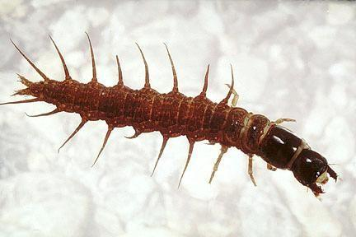 | Scientific name:  What does it eat?  What are its predators?  Interesting fact:
Water-penny beetle larvae  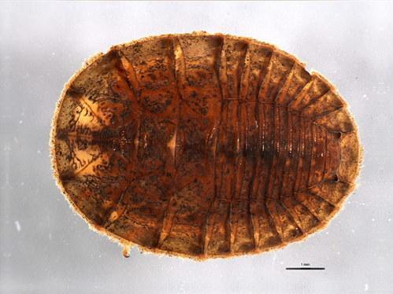 | Scientific name:  What does it eat?  What are its predators?  Interesting fact:
Great blue heron  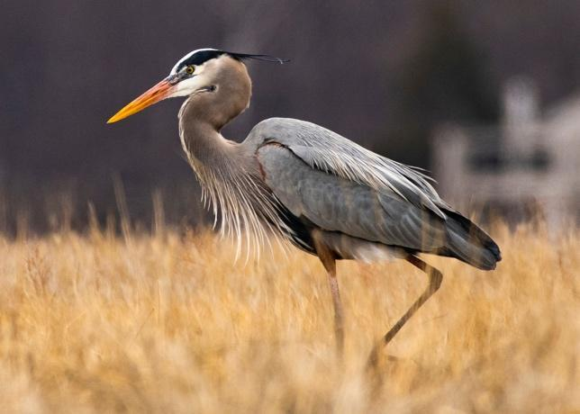 | Scientific name:  What does it eat?  What are its predators?  Interesting fact:
Appalachian brook crayfish  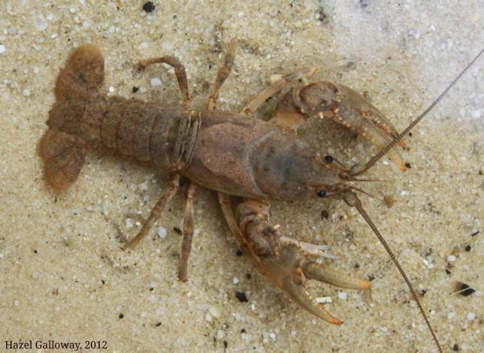 | Scientific name:  What does it eat?  What are its predators?  Interesting fact:
Northern water snake  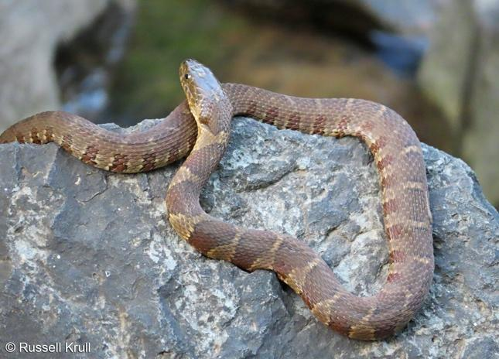 | Scientific name:  What does it eat?  What are its predators?  Interesting fact:
Benthic algae  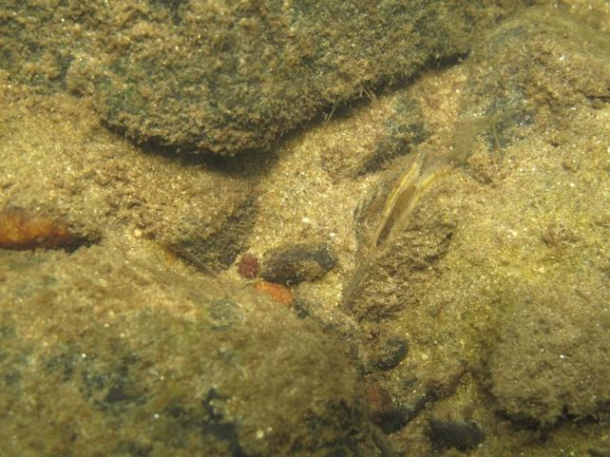 | What is it?  How does it get its food?  What eats it?  Interesting fact:
Leaf detritus  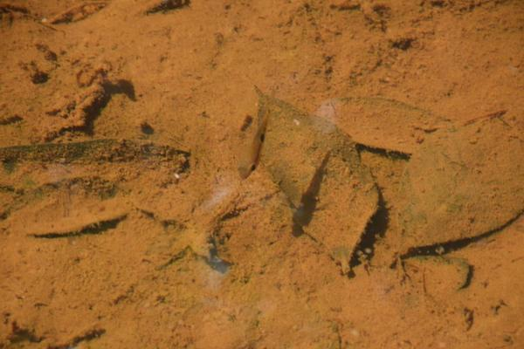 | Scientific name:  What does it eat?  What are its predators?  Interesting fact:
Leech  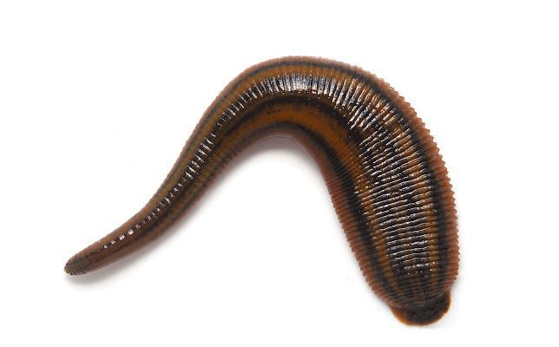 | Scientific name:  What does it eat?  What are its predators?  Interesting fact:
Belted kingfisher  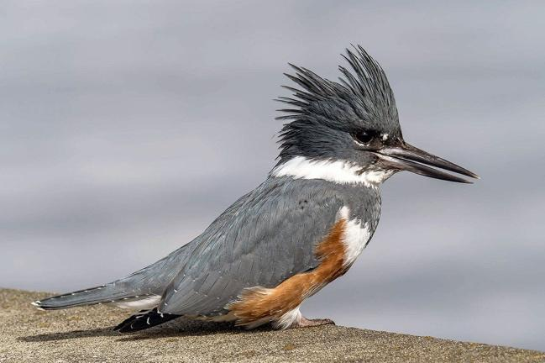 | Scientific name:  What does it eat?  What are its predators?  Interesting fact:
Freshwater amphipod  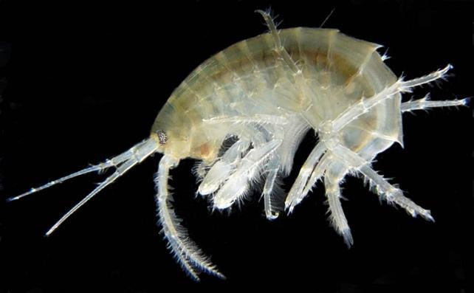 | Scientific name:  What does it eat?  What are its predators?  Interesting fact:
Asian clam  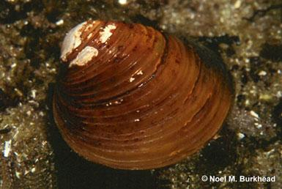 | Scientific name:  What does it eat?  What are its predators?  Interesting fact:

