NAME: _______________________________________ DATE: ________________ CLASS PERIOD: _____

YOUR IMPAIRED WATERWAYS
Hellbender Education

BACKGROUND: Today, we’re going to use Google Earth – just like we did at the beginning of class – to map a few rivers and streams in our local watershed. Waterways that pass close to or through urban or dense agricultural areas tend to be highly impacted by surrounding human activity, and the effects that we have on those rivers and streams can easily be carried downstream to impact other parts of the watershed. In this exercise, you’ll be focusing on a few streams or rivers that have been classified as “Impaired” by the Environmental Protection Agency (EPA) and drawing some conclusions about human activities that you think might be affecting water quality and organisms living there.

PRE-ACTIVITY QUESTIONS: Answer this question with your partner before you start the activity.

Make a list of ways that you think water quality (and thus organisms) might be affected by human activity in each of the following types of locations: any ideas for other locations, please suggest!

URBAN (within the city):

SUBURBAN (small neighborhoods on the outskirts of the city):

RURAL MINING/INDUSTRIAL:

RURAL AGRICULTURAL:

RURAL NON-AGRICULTURAL:

PROCEDURE:
- Double click the file on the desktop called “waterskmz_v1.10.kmz” – it should open in the Google Earth application.

- On the left side of the screen in Google Earth, you will see a list of boxes that can be checked and unchecked – these will label things on the map according to EPA data. For now, make sure that all of the boxes are unchecked.

- Double click on your local area on the globe, and zoom in until you can find the nearest labeled large town or city. For example, if you live in Louisville, TN (which is about 23 minutes away from Knoxville), you should zoom in until your screen is largely comprised of the city of Knoxville, TN.

- Once you’ve focused on the nearest large town or city, check the box in the panel to the left that says “Streams” (under the “Surfacewater Features” section). You should see a bunch of blue lines appear on your map.

- Use your mouse to click on a few of these rivers and streams until you find one that is familiar to you.

Question: Which stream or river names do you recognize? Have you ever been to any of these rivers or streams? Do you remember anything about what they were like? What did you do there? Please answer with a short descriptive paragraph.

- Now try to find a few rivers/streams that fit into some of the same categories we discussed at the start of the lab, and write their names in the appropriate spaces below:

URBAN:

SUBURBAN:

RURAL:

- Find one stream or river from each of the above categories, click on it, and when the window pops up, click on “Watershed Report” under the “Tools” section. This will open a browser window with some data from the EPA. Use this information to fill in the following blanks (if there is no stream name, write “Not Available”).
URBAN STREAM

Stream name: ___________________________________ Stream order: _______

Land cover:
Low intensity residential: _______ Commercial: _______

Forest: _______ (add up all forest types) Other: _______

SUBURBAN STREAM

Stream name: ___________________________________ Stream order: _______

Land cover:
Low intensity residential: _______ Commercial: _______

Forest: _______ (add up all forest types) Other: _______

RURAL STREAM

Stream name: ___________________________________ Stream order: _______

Land cover:
Low intensity residential: _______ Commercial: _______

Forest: _______ (add up all forest types) Other: _______

Predict: Which of these streams might you expect to be the most impacted by human activity? Why? Are there any patterns in land cover that you noticed in the EPA data that you used to fill in the blanks above?

- Return to Google Earth and check the box in the panel to the left that says “303(d) Listed Impaired Waters” (under the “EPA Linked Data” section). You should see some of the blue lines on your map turn red.

Question: Are any of the streams you chose in step 7 red now? If so, which ones? These represent Impaired Waters, a status given by the EPA to waterways which are more heavily polluted. Do any of these match your prediction from before?

- Now let’s take a look at some organisms that might live in these streams! Conservation biologists and ecologists often look at the presence or absence of certain species of animals and plants to give them an idea of the health of an ecosystem – these organisms are called bioindicators, and they usually have a range of tolerances to pollution. If you find a lot of very tolerant species, but no intolerant ones, the river or stream is likely polluted. Similarly, if you find a lot of species that are very sensitive to pollution, but few or no tolerant ones, then this indicates that the river or stream is healthy. Examine the chart below:

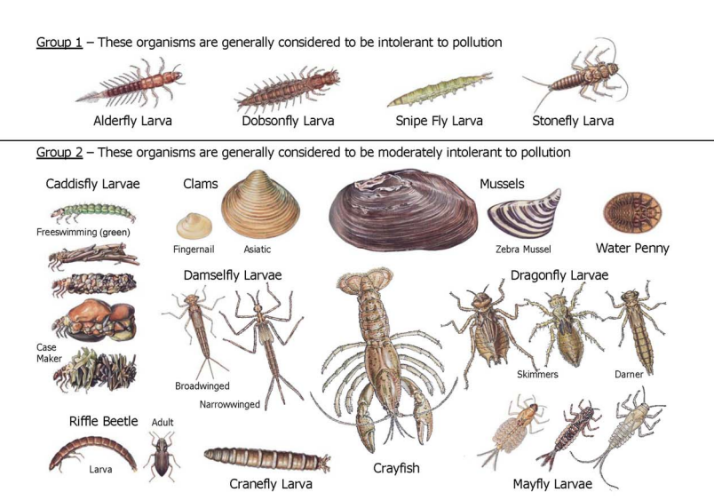
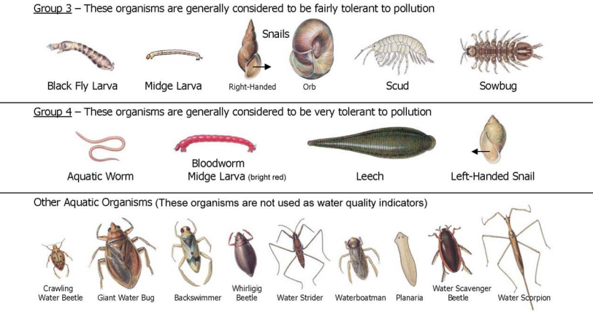
"Macroinvertebrate Monitoring." Macroinvertebrate Monitoring (n.d.): Newman Boston. The Newman School. Web. 29 Mar. 2016.
The data table below is a hypothetical sample of invertebrates collected from the three different streams you chose in Step 7. Using the chart on the previous page, fill in the blanks in the last column of the table to predict where each stream is located.

STREAM | SPECIES | NUMBER IN SAMPLE | URBAN, SUBURBAN, OR RURAL?
1 | Fingernail clam | 23
 | Crayfish | 4
 | Black Fly larvae | 17
 | Aquatic worm | 2
 | Mayfly larva | 14
2 | Snipe fly larva | 7
 | Stonefly larva | 13
 | Fingernail clam | 5
 | Dobson fly larva | 9
 | Dragonfly larva | 6
3 | Cranefly larva | 7
 | Left-handed snail | 14
 | Riffle beetle | 6
 | Bloodworm | 9
 | Leech | 7

Question: Do you think it’s true that the most polluted streams are always urban? Can you think of some reasons why rural streams in some places might be just as heavily impacted by human activity? Explain.

Question: Hellbender salamanders also are particularly sensitive to water quality. They require clean and fast-moving, well-oxygenated water with large rocks. Which stream order(s) would most likely support healthy populations of hellbenders? In which streams on your Google Earth map would you most likely find hellbenders living?

