NAME: ________________________________________ DATE: _______________ CLASS PERIOD: _______

NOTES SHEET: WATERSHEDS AND HUMAN IMPACTS
Hellbender Education
How do we define the scale of a watershed?
- Generally, the larger a waterway, the __________________ its watershed
- Smaller waterways, like _________________ and small ________________, also have watersheds, but they are smaller!
- Think of it like nesting bowls: the watershed of a tiny stream is a small part of the watershed of a large river.

Where is the closest watershed to me?
- You’re in one ______________________!
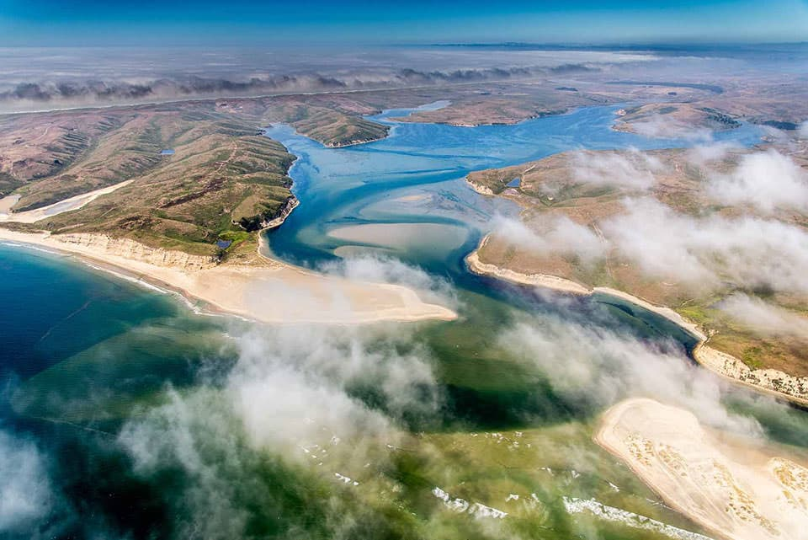
- Everyone lives in a watershed - rainwater that falls right here will flow into a body of water (which likely flows into another)
- Everything we do to the _________________________________ has the potential to affect the _________________________________ because of ______________________ through watersheds

Where does all the rainwater go?
- Much of it ends up in the oceans
- A lot of rainwater can soak into, or __________________, the ground to become part of the ______________________
- This depends on soil type – hard clay soils are less ______________________, so water tends to flow over them toward lower ground
- The movement of this water connects large areas of land
- Impacts that _______________ have on water in one area can greatly affect water in another.

Human Impacts in Watersheds
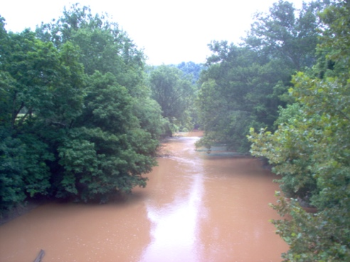
Deforestation:
- Removal of trees __________________________________
- More ______________________ flows into waterways (not held in place by tree roots anymore!)
- Think: What would this mean for hellbender salamanders? For other organisms living in streams and rivers?

Urban construction:
- _______________ and construction of large buildings – how does this affect water flow?
  - Water can’t _______________, and therefore lots of runoff is generated
  - Can lead to _______________
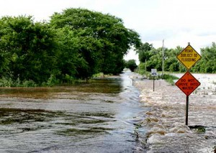
- Runoff from urban areas picks up all kinds of _______________ and _______________ as it moves across these hard surfaces
- Ends up in surface and groundwater _____________________

Farming:
- Farmland must be cleared of __________ first!
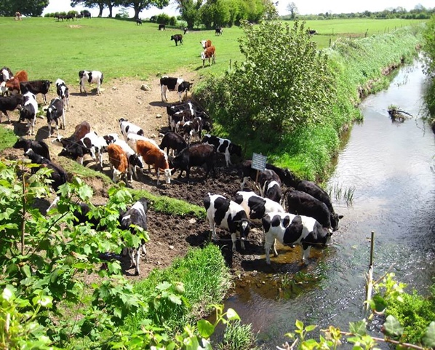
- Carried by rainwater into streams:
  - ____________________: can cause overgrowth of algae and a reduction in dissolved oxygen
  - ____________________: toxic to many organisms
- Animals grazing in the _________________________ (the interface between a waterway and the surrounding terrestrial environment)
  - _________________ banks
  - Direct deposition of ________________

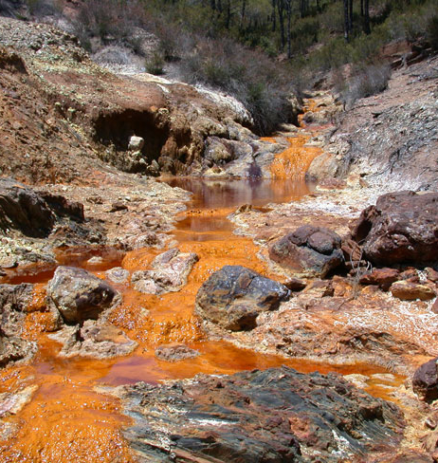
Mining:
- Construction of mines:
  - creates impervious surfaces like ____________
  - often involves the use of explosives for ___________________, which can drastically alter water flow patterns
- Introduction of toxic _______________________________ to water
- ____________________________ from mines can disrupt the _____ of waterways

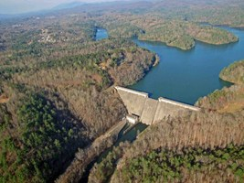
Hydroelectric dams
- Alter flow patterns, often flooding large areas
- Slower-moving water resulting from dam construction is often much ___________________
- Can limit the flow of important _________________ to downstream areas
- Prevent movement of ___________________________ ______________________________

