NAME: _____________________________________ DATE: _________________ CLASS PERIOD: ________
BUILD A WATERSHED!
Hellbender Education
BACKGROUND: Watersheds, whether small or large, connect people, places, plants, animals, and habitats. A little creek behind your house has a watershed that is relatively small, while the Mississippi River watershed takes up about 40% of the continental United States - it’s the fourth largest in the world behind only the Amazon, the Nile, and the Congo River watersheds! Let’s start by discussing some important vocabulary that we use to describe and classify waterways within a watershed.

PRE-LAB VOCABULARY: The following are words that we use to describe waterways and other features in watersheds – do you know what they mean already? Fill in what you can, and then we’ll go over them together as a class!

Creek/Stream/River:

Drainage:

Headwater:

Tributary:

Confluence:

Permanent stream:

Intermittent stream:

Ephemeral stream

Riparian zone (buffer):

PRE-LAB QUESTIONS: In this section, we’ll discuss one of the most important ways that we describe waterways in a watershed: stream order. We use stream order numbers to classify waterways based on the number of tributaries flowing into them.

Take a look at the picture displayed at the front of the class. Based on the way that streams are numbered in the picture, see if you can come up with three rules for determining stream order, and write them here:

Rule 1: ___________________________________________________________________________
______________________________________________________________________________________________________________________________________________________

Rule 2: ___________________________________________________________________________
______________________________________________________________________________________________________________________________________________________

Rule 3: ___________________________________________________________________________
______________________________________________________________________________________________________________________________________________________

Now let’s discuss the rules that you came up with together! Make any adjustments to your rules to reflect our discussion – you’ll be asked to diagram your watershed and label the order of its waterways.

MATERIALS:
- Large aluminum pan
- Sand, dirt, and/or gravel
- Large piece of aluminum foil
- Pen/pencil and colored pencils or markers
- Spray bottle filled with water
- Food coloring or different-colored liquid

PROCEDURE:
- Fill your aluminum pan with a mixture of sand, dirt, and/or gravel.

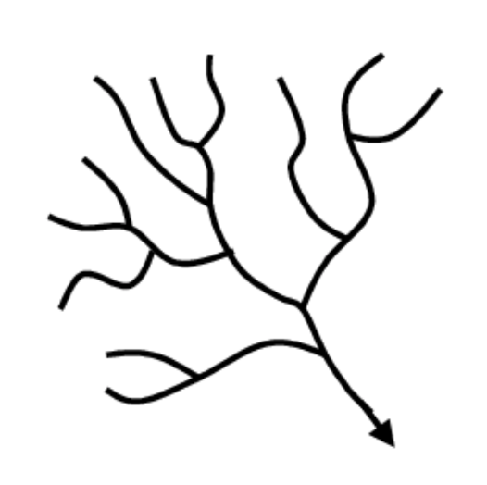
- Make small peaks and valleys in the mixture to simulate topography (mountains, hills, valleys, ridges, etc.). Try to make these features exaggerated, as that will result in a better watershed simulation later in the activity.

- Lay your sheet of aluminum foil down over the mixture and carefully pack it down against the topographical features you created in step 2. You can use the foil to create small peaks and valleys in addition to the larger ones. Be careful not to tear the foil!

- On the next page, diagram how you think water will flow through your watershed, using a simple line drawing like the example to the right. Label the stream orders on your diagram according to the rules from the pre-lab.

BEFORE you add any water: DRAW YOUR DIAGRAM OF YOUR WATERSHED IN THIS SPACE!
Work with your partner to label the following on your diagram: 1) stream order for each waterway, 2) confluences (label with C), and 3) direction of water flow (use arrows).

Questions:
- Are there parts of your foil sheet that empty into a different watershed (one that you’ve only captured a small part of)? Explain.

- If water could soak through the aluminum foil, what might the sand/dirt/gravel underneath it represent?

- Predict: If a toxic chemical is introduced to the watershed, would it have a larger area of impact if it were introduced to a 1st order waterway or a 4th order waterway? Why?

Now, use your spray bottle to introduce “precipitation” to your watershed! Be sure to spray it all over, and spray it enough that water starts to flow across the surface of your aluminum foil.
AFTER you add any water: DRAW YOUR DIAGRAM OF YOUR WATERSHED IN THIS SPACE!
Work with your partner to label the following on your diagram: 1) stream order for each waterway, 2) confluences (label with C), and 3) direction of water flow (use arrows).

Finally, add a few small drops of food coloring (to simulate the introduction of a “toxic contaminant” to the following places in your watershed:
- A 1st order waterway
- A 2nd order waterway
- A 3rd order waterway

Questions:
- How did your actual watershed compare to the one you drew before you added the water? What were some of the major similarities? What about major differences?

- What happened when you added the food coloring? What was different about the flow of the “toxic contaminant” when you added it to the different waterways?

- Which parts of your watershed (stream orders) would you expect to be impacted the most by urban development? Farming? Explain your answer.

- If you were a conservationist interested in protecting the watershed, which parts would you target first? Why?

- Let’s say you live in this watershed, along the banks of a 2nd order stream. There are small neighborhoods on either side of yours – both upstream and downstream. The stream suddenly begins to show signs of degradation, and folks in the community are getting upset. What could be the cause of this change in water quality? Who is to blame? Whose responsibility is it to find a viable solution?

