NAME: __________________________________ DATE: _________________ CLASS PERIOD: ______
STUDENT NOTES SHEET:
SPECIES, SPECIATION, AND HELLBENDER TAXONOMY
Part 1: What is a Species?
Summarize three key points from the video that we just watched.

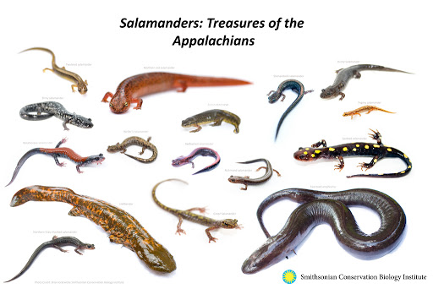
Part 2: Islands in the Sky
Appalachian salamander diversity
- More species of salamanders in Appalachia - _______ of all species – than in any other place in the world!
- Why do we live in such a hotspot? What is it about Appalachia that gives rise to so many species?
  - ____________ - seasonal temperatures, ____________, etc.
  - Elevation
  - ____________________

What is it about mountains?
- For salamanders, mountains are like __________________!

This is called __________________________________________.
- When two populations of the same species become separated by a _______________________________.
- Over long periods of time _____________________________________ (_____________________ isolation), those populations accumulate _________________ differences
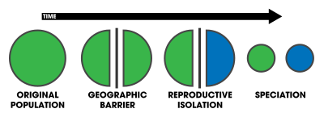
The importance of biodiversity
- If there are plenty of plants and animals, why should we worry about how many different species there are?
- Remember that different species fulfill _______________________ in ecosystems – their ecological ______________
- The more species there are, the more niches are being filled – the more _______________ an ecosystem is (and the more _________________ it provides to humans!)
So, where do hellbenders fit in?
Kingdom: Animalia
Phylum: Vertebrate
Class: Amphibia
Order: Caudata
Family: Cryptobranchidae
Genus and species: Cryptobranchus alleganiensis
Can you name a few other amphibians? _______________________________________________________
Are hellbenders more closely related to lizards or frogs? __________________ How do you know?

How do we calculate diversity? Let’s say we just go by how many different species there are in an area. Is this a good way to measure how “diverse” an area is? Why or why not?

Species Richness
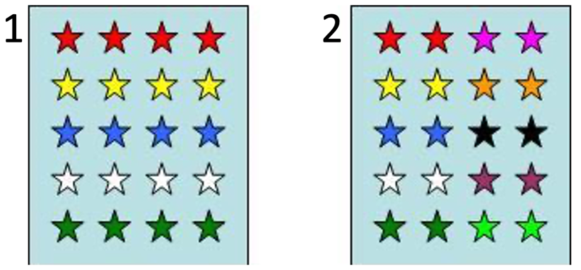
________________________ = species richness

Which community has a higher species richness?

1 OR 2

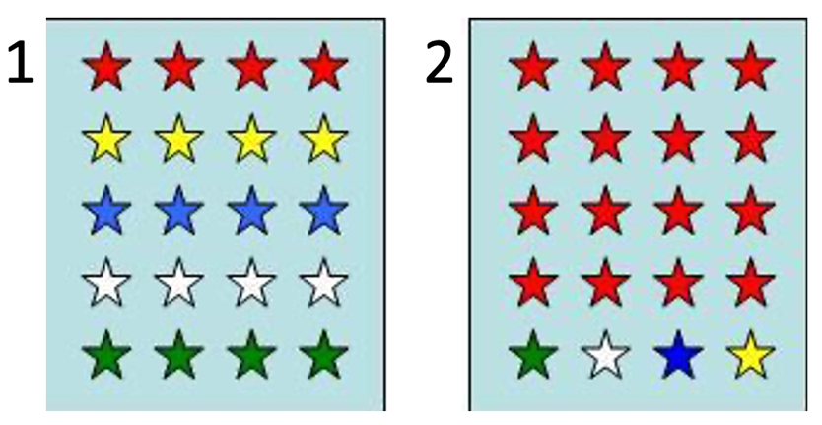
How about this one? 1 OR 2

But which one would you say is more diverse?

1 OR 2

Species evenness
- How “__________________________” each species is (how many individuals of each species there are) = species evenness

Community _____ has a higher species evenness!

